First Tuesday of the month
The North Bristol Alzheimer Café
at
St Monica Trust,
Oatley House Atrium restaurant
Westbury-on-Trym, Bristol, BS9 3TN
3.30pm – 5.30pm

April 2016
This leaflet contains information about the North Bristol Alzheimer Café at St Monica Trust.

The purpose of the Alzheimer Café:
The purpose of the café is to provide a relaxed and safe space in which issues surrounding dementia can be aired in a friendly and informal environment.

What we provide:
Our café is staffed by trained and experienced volunteers who care about people living with dementia. You will find a very relaxed and friendly atmosphere. Our café provides families, supporters and professionals with the opportunity to share their feelings and discuss problems. It also allows people to give and receive support, guidance and information. We also feel the café provides a pleasant social event for everyone to enjoy. Every week refreshments are served and most weeks live music is played.

Some practical details:
- There is no charge to attend the café and refreshments are free.
- Free on-site parking is usually available.
- Bristol’s number 1 bus stops right outside the main gate.
A typical session:
Each session includes refreshments such as tea, coffee, sandwiches and delicious home-made cakes.
Every month we have speakers who will share a conversation about a subject which is linked to the area of dementia, or themes for the afternoon. Please see the rolling programme of themed talks overleaf. There will also be opportunities for you to ask your own questions and pick up useful resources from our information table.
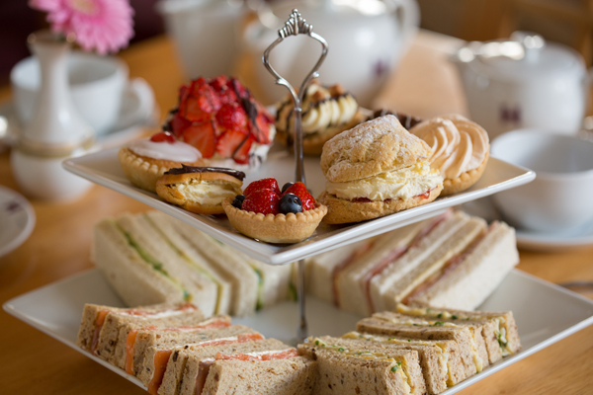

“Come out of the woodwork; you are part of Society and we want you to take your part in it. Dementia is part of life for some, for which nothing yet can be done. You didn’t ask to get it; it could happen to anybody. Don’t hide away.”
Dr. Bere Miesen, Alzheimer Café Founder
Annual rolling programme of talks:

Date 2016 | North Bristol talks – themes*
7th June  5th July  2nd August  6th September  4th October  1st November  6th December | Chair Ballet - The benefits of music and movement  ‘Growing support’. Gardening and horticulture  Dementia friendly home environments  Assistive technology  Helping people to cope with changing senses  Bonfire Night theme  Christmas event
*Themes may change
For further information or to register your attendance, please contact Jacqui Ramus (Dementia Lead for St Monica Trust) on 07854 185 093 or by email to jacqui.ramus@stmonicatrust.org.uk

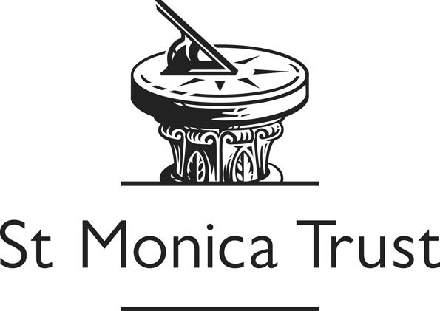

/tmp/in/input.doc

