

Community Learning & Impact Report
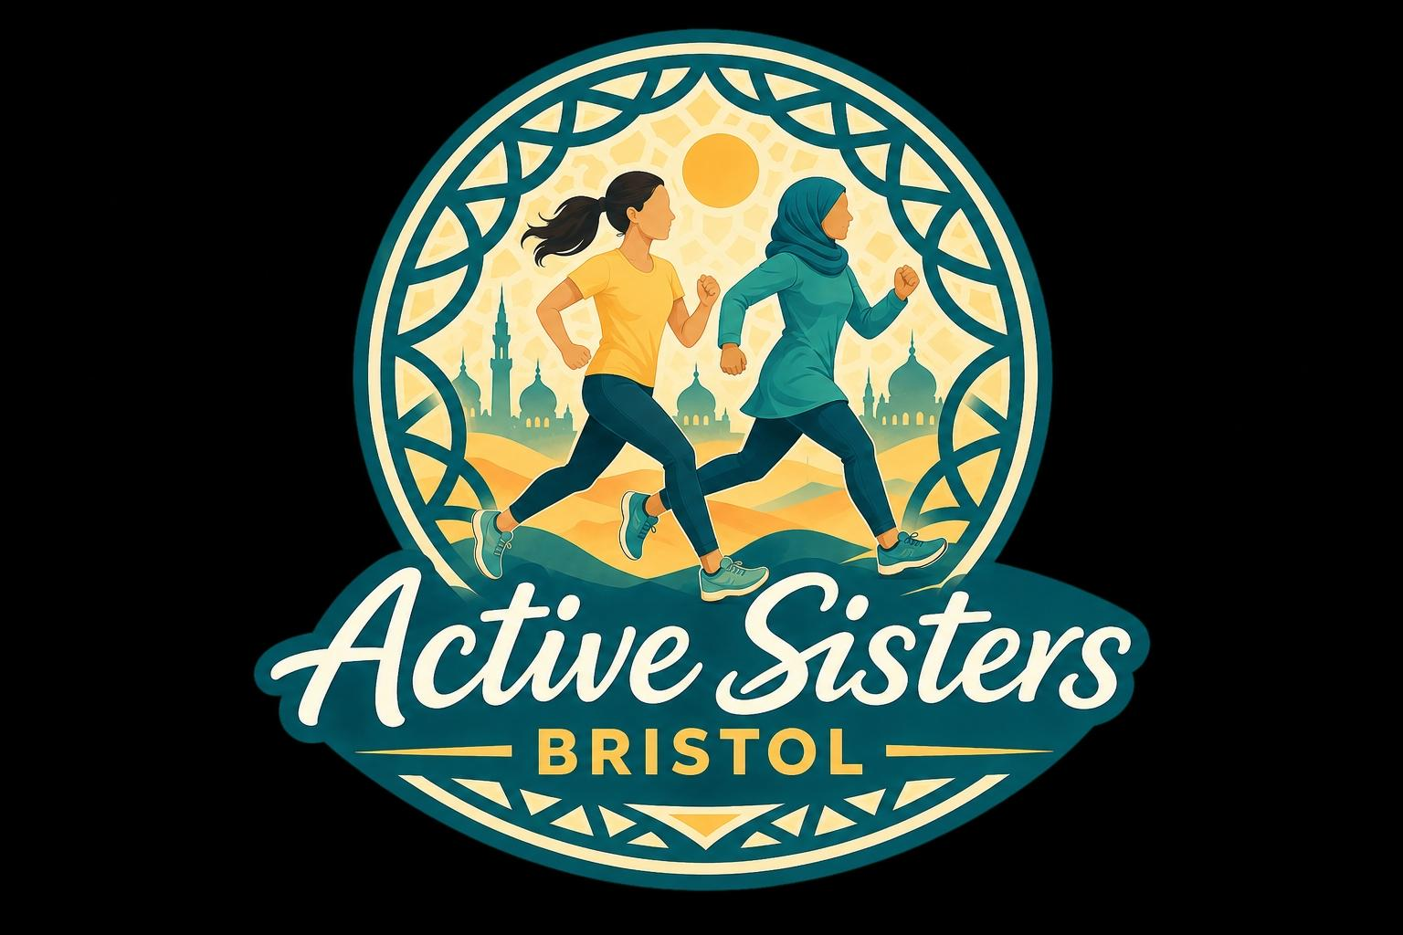

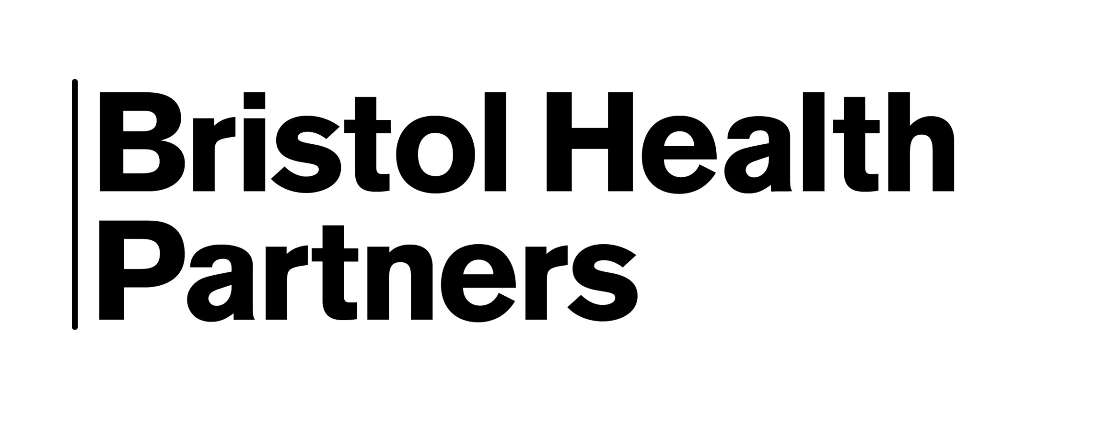
Report author: Samina Baig, Caafi Health Research Ambassador,
On behalf of Bristol City Council & Bristol Health Partners,
Active Lives Health Integration Team

2026

Executive summary
Active Sisters Bristol was commissioned by Bristol City Council and Bristol Health Partners’ Active Lives Health Integration Team as a community engagement and test-and-learn project exploring how physical activity opportunities could be improved for Muslim women and girls in Bristol. The project was delivered through a three-stage approach of Listen, Learn and Act, designed to understand community experiences, identify barriers and test practical solutions that could support participation in physical activity.
The project began by engaging with stakeholders from health, sport, physical activity and community organisations, alongside mosques and faith-based organisations across Bristol. This engagement demonstrated that while physical activity opportunities already exist, access is often influenced by factors such as affordability, confidence, awareness, location, childcare responsibilities, cultural considerations, women-only provision and the availability of female instructors.
The second stage focused on hearing directly from Muslim women and girls through community focus groups, questionnaires and ongoing conversations. Women and girls reported interests in a wide range of physical activities, but highlighted practical, social and cultural barriers that affected participation. Importantly, the findings showed that increasing physical activity is not simply about providing more sessions. Social connection, motivation, encouragement, accountability, confidence and culturally relevant opportunities were identified as equally important factors in supporting sustained participation.
The project then tested three pilot programmes:
- Step Together Challenge, a four-week walking initiative combining physical activity with peer support, motivation, accountability and wellbeing messages.
- Strength & Flexibility, a beginner-friendly women-only exercise programme delivered by a female instructor.
- Netball, a women-only team sport programme designed to promote physical activity, friendship, confidence and social connection.
The pilots generated strong community interest and demand. Registrations exceeded available places for both the Strength & Flexibility and Netball programmes, while the Step Together Challenge created a supportive community network that collectively recorded more than 2.45 million steps over four weeks. Across all three pilots, participants reported increased confidence, motivation and willingness to continue being physically active. Women also described improvements in wellbeing, social connection, sense of belonging and confidence to participate in future activities.
A significant finding from the project was that culturally inclusive physical activity requires more than women-only sessions. Effective participation was supported by trusted relationships, community ownership, female instructors, accessible venues, affordability, privacy, flexibility and opportunities that reflected the realities of women's lives. The project highlighted the importance of designing programmes with communities rather than for communities.
The impact extended beyond the original pilot activities. New opportunities emerged through partnerships with WeSport, the Lawn Tennis Association, community organisations and local women interested in developing leadership and coaching roles. The project also led to the creation of the Active Sisters Bristol identity, providing a recognised platform through which future activities, partnerships and community leadership opportunities can continue to develop.
The project demonstrates that Muslim women and girls in Bristol are interested in being physically active and are willing to participate when opportunities are accessible, culturally responsive and community-led. The findings suggest that future investment should focus not only on activities themselves, but also on community capacity, coordination, leadership development and sustainable partnerships that can support long-term participation and help reduce health inequalities.
The project's most important achievement cannot be measured in steps alone. It can be found in the confidence built, the friendships created, the women returning to activity, the leaders beginning to emerge and the foundations established for a more active and connected community of Muslim women and girls in Bristol.
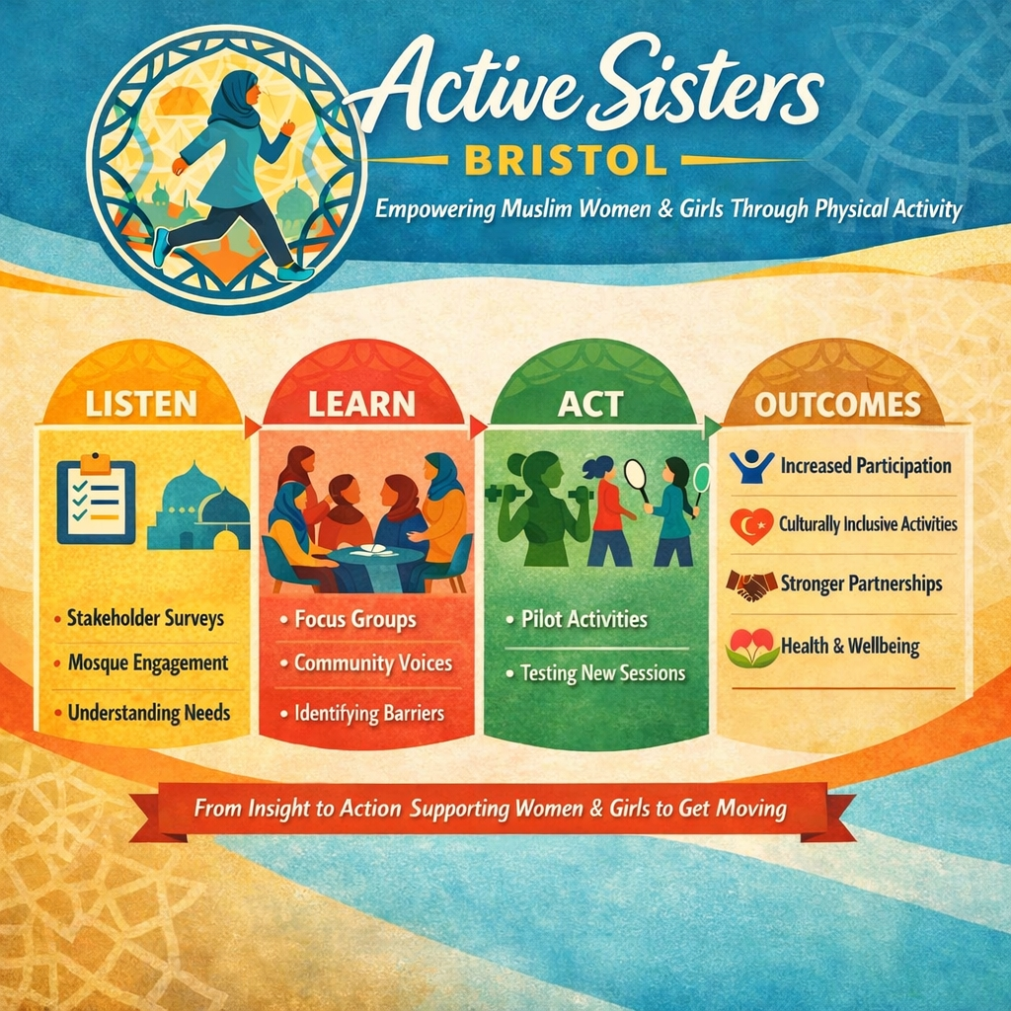

1. OUR JOURNEY

Building on Community Trust

Active Sisters Bristol did not begin with a blank sheet of paper. It grew from relationships, conversations and learning developed through previous community health work.
In 2023, after becoming a Health Ambassador with CaafiHealth, one of my first projects was the Healthy Madrasah Research Project, exploring how faith-based settings could help address obesity and support healthier lifestyles among Muslim children.
This was followed by involvement in a project with Maximus, looking at health and wellbeing among South Asian Muslim women.
Both programmes created opportunities to build relationships within the community and prompted wider conversations about health, wellbeing and healthy lifestyles. This work organically created momentum and growing interest in physical activity opportunities that felt relevant, accessible and appropriate for Muslim women and girls.
It was against this background that the Active Lives Health Integration Team (HIT) and Bristol City Council approached CaafiHealth to undertake a community engagement and test-and-learn project focused on physical activity among Muslim women and girls in Bristol.
Rather than deciding in advance what activities women and girls needed, the project first sought to understand the wider picture, then listen directly to community voices before testing different approaches to physical activity.

2. LISTEN

Understanding the Wider System
The first stage was to listen to organisations already working with communities across Bristol. Engagement included 23 stakeholders from health, sport, physical activity and community organisations and 9 mosques, faith and community organisations.
This helped us understand what organisations were seeing, what provision already existed and where they believed the gaps and barriers were.
Importantly, the findings showed that the issue was not simply a lack of physical activity provision. There were already activities available across Bristol. The challenge was whether women and girls could access them, felt comfortable using them, knew about them and felt that the opportunities fitted their lives and circumstances.

Recognising What Already Exists
- Active Sisters Bristol was not developed in isolation, and the project does not suggest that physical activity opportunities for Muslim women and girls were absent from Bristol.
- There are already community members, volunteers, mosques, community organisations, sports organisations and individuals working to create opportunities for women and girls to be active. Stakeholder engagement highlighted a range of existing activities and demonstrated a willingness among organisations to support future opportunities.
- The purpose of this project was therefore not to replace or duplicate work that is already happening. Instead, it sought to understand what women and girls experience when trying to access existing opportunities, where gaps or barriers remain, and how existing community strengths and partnerships could be built upon.
- This distinction is important. The challenge is not simply creating more activities. It is also about connecting existing efforts, increasing awareness, addressing barriers to participation, creating opportunities that feel culturally appropriate and accessible, and supporting community-led activity to become more sustainable.
- Active Sisters Bristol should therefore be seen as building on what already exists, connecting people and opportunities, and creating space to test what additional approaches might work for women and girls who are not currently being reached.

2.1 Stakeholder Engagement
The stakeholder survey showed that Muslim women and girls were already accessing some existing provision. Of the 23 stakeholders responding, 13 said Muslim women and girls accessed their activities frequently, 3 occasionally, 2 rarely, 4 were not currently accessing their activities and 1 was unsure.

Key barriers identified
- Cultural or faith considerations
- Cost
- Limited women-only provision
- Lack of female instructors
- Confidence and comfort
- Childcare and caring responsibilities
- Lack of awareness of existing activities
- Availability of suitable venues
- Transport and locality

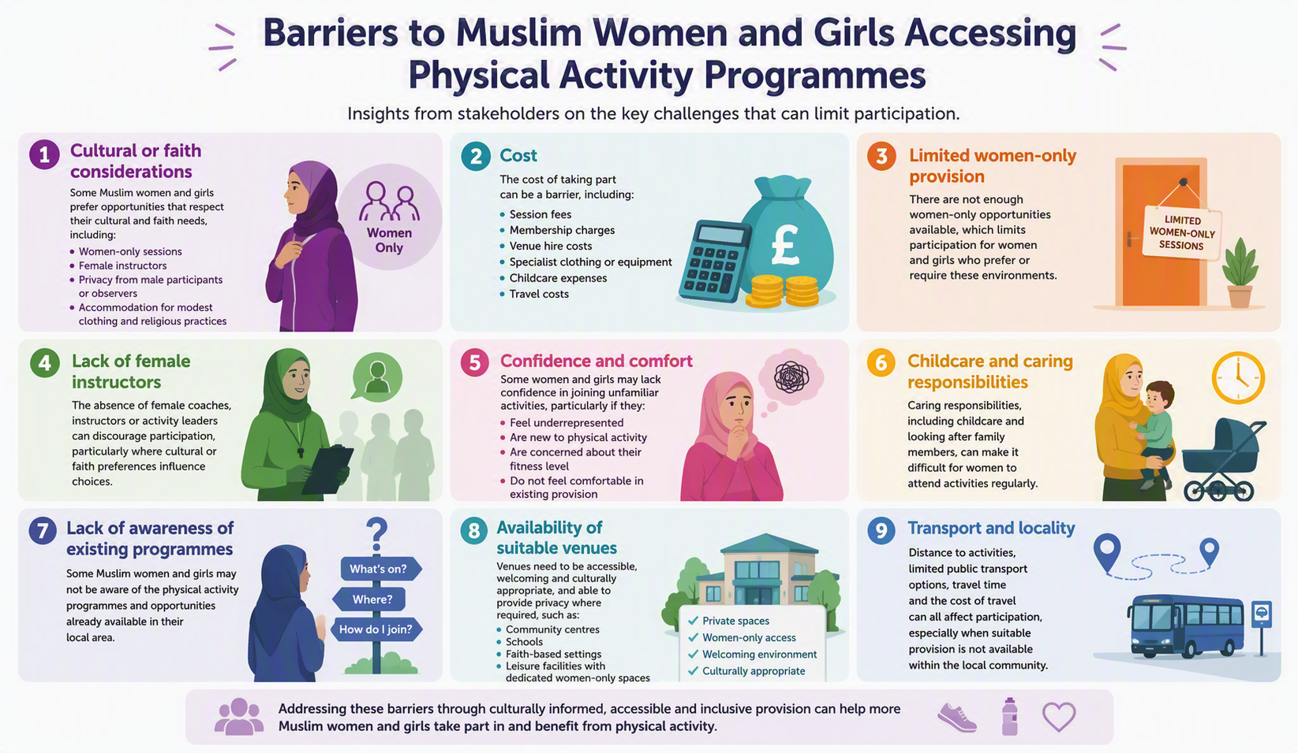
Fig 2: Barriers to engagement with physical activity programmes among Bristol Muslim women

Safe and appropriate environments
Stakeholders highlighted the importance of women-only sessions, female instructors, privacy, suitable changing facilities, appropriate sports clothing and consideration of hijab and modesty requirements.

Location, accessibility and cost
Stakeholders highlighted the importance of local, community-based venues and provision that women can reach without significant travel. Affordability was another recurring theme. Venue costs, instructors, workforce capacity, childcare and coordination can all affect whether activities can be established and sustained.

Potential activities
Stakeholders identified a wide range of activities, including walking, swimming, Pilates, yoga, badminton, dance, football, netball, basketball, running, strength and flexibility, tennis and Padel. This reinforced the importance of offering choice rather than assuming one activity will suit everyone
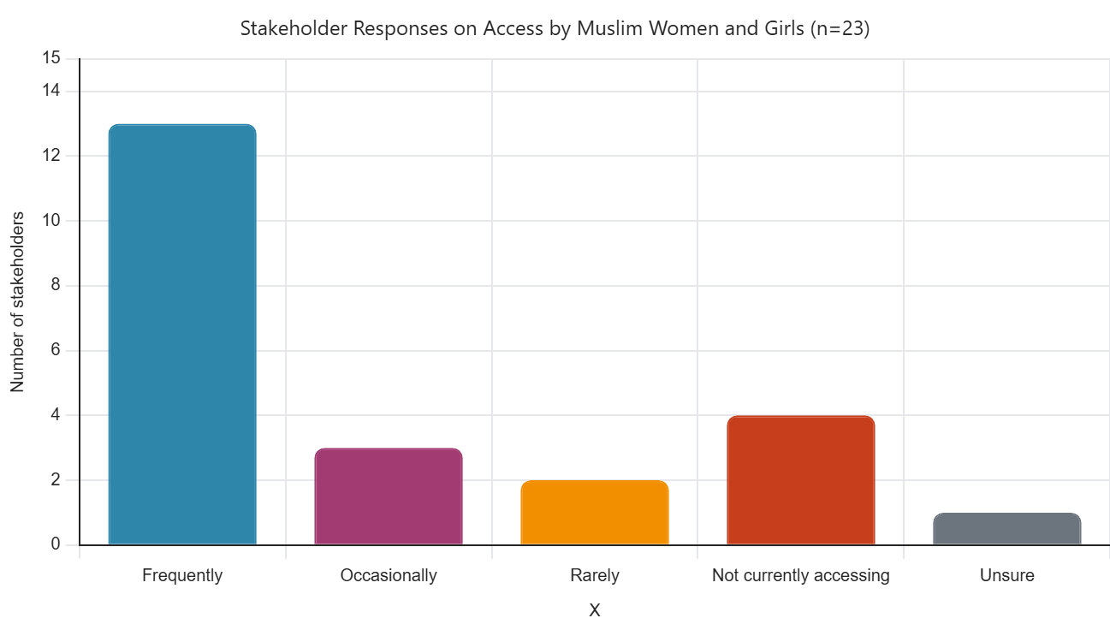
Fig 3: Access to physical activity programmes by Muslim women & girls

2.2 Mosque & Faith/Community Engagement
The mosque and faith/community engagement reinforced many of the stakeholder findings. All 9 respondents felt there was a need for more opportunities for Muslim women and girls to be physically active.
Strong areas of interest included young girls, family-based physical activity, women-only fitness, walking groups, badminton and other sports, and strength/gym-based sessions. Women-only swimming was also identified.

What needs to be considered?
- Privacy
- Female instructors
- Appropriate clothing
- Age-appropriate provision
- Accessibility
- Affordable or free sessions
- Timing
- Location
- Changing facilities
- Language
- Family commitments
Some respondents also highlighted the value of flexibility, including the option to attend individual sessions rather than always committing to a longer programme.

Are mosques the answer?
Not necessarily for every activity!
Mosques can play an important role in supporting physical activity. They are trusted, familiar and culturally relevant spaces for many women and families. However, the project highlighted that activities do not necessarily need to be organised or delivered by mosques themselves.
Where activities are promoted primarily through an individual mosque, they may predominantly reach women who are already connected to that mosque. This can unintentionally limit participation from women in the wider community, including women from different ethnic and cultural backgrounds or those who do not regularly attend the mosque.
In contrast, activities developed with and by women from the community can provide a more inclusive space where women from different backgrounds come together around a shared interest rather than their connection to a particular mosque.
There are also practical capacity issues. Although mosques may be keen to support more opportunities for women and girls, many operate with limited space, resources and volunteer capacity. Volunteers are often balancing the day-to-day running of the mosque alongside faith-based activities and other community responsibilities. Historically, activities for men and boys may also take priority simply because of how existing structures and volunteer capacity have developed, meaning opportunities for women and girls can be overlooked despite good intentions.
This suggests that mosques should be viewed as important partners within a wider community network, rather than the only route through which culturally appropriate physical activity is provided. Community centres, parks, sports facilities and other trusted spaces can complement mosque-based provision and help reach women who may not otherwise engage.

Willingness to support physical activity offerings for Muslim girls and women
Organisations identified ways through which they could support future physical activity programmes including sharing information, outreach, connecting with women's groups, hosting activities, providing advice and helping mobilise the community.

2.3 What we learnt from LISTEN
The stakeholder and mosques engagement showed existing interest in physical activity, a willingness to support programmes, strong preference for women-only opportunities, a need for affordable and accessible provision, better communication and awareness, and an opportunity to build on existing community partnerships.
However, we did not want organisations to speak on behalf of women and girls. The next stage was therefore to listen directly to the people the project was intended to support.

3. LEARN

The second stage focused on community voices through a women's community focus group (n=8), girls' surveys (n=12) and wider conversations with women involved in the project. This moved from asking what organisations thought women needed to asking what women and girls themselves said they needed.

3.1 Women's Community Focus Group
Women described existing engagement with a wide range of activities including walking, yoga, Pilates, cycling, Bollywood aerobics, Nordic walking, gardening, badminton, boxing and family sports. The challenge was therefore not simply that women were inactive, but understanding what could help women start, maintain or increase physical activity within the realities of their lives.
Themes emerging from the focus group data also highlighted the barriers identified by the organisations in the Listen stage, including accessible local venues; women-only and safe spaces; female instructors; family and caring responsibilities; cost and practical access; and flexible engagement opportunities. The women also highlighted the lack of individual and social motivation to start and maintain engagement with physical activity. For example, they were not part of groups where they felt a sense of responsibility to fellow group members to exercise and continue to engage with physical activity.

Teenage girls
One of the key findings from the focus group was that women reported a significant drop in physical activity among teenage girls due to body image concerns, fear of judgement, social media pressures, cost, gym age restrictions, lack of modest sportswear and limited opportunities designed specifically for teenage girls. The women highlighted the link between this behaviour change and the subsequent life-long reluctance to engage in physical activity, which does not only impact the teenage girl as she grows to be a woman, but also how she might influence physical activity behaviours of others when the time comes for her to start a family.

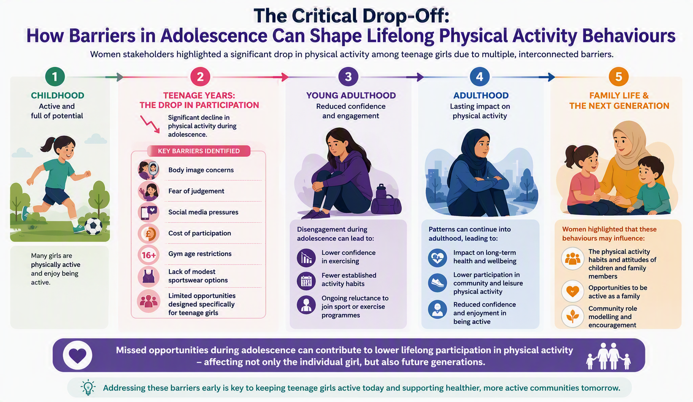

Fig 4: The long-term implications of reducing physical activity during teenage years

Motivation as a barrier
One of the important learning points from the community insight was that knowing physical activity is important does not necessarily translate into being physically active.
Women and girls may understand the benefits of exercise but still experience barriers around motivation, time, confidence, competing family responsibilities and finding activities that feel enjoyable and relevant to them.
The learning suggests that motivation may be strengthened through:
- Accountability;
- Encouragement from other women;
- Companionship and social connection;
- Recognition and positive reinforcement;
- Accessible and welcoming opportunities;
- Culturally relevant messaging; and
- Support from trusted people within the community.
This is important because it suggests that increasing physical activity cannot be approached solely by providing more activities. The way people are supported and motivated to participate is equally important.

3.2 Girls' Insight
The girls' questionnaire (n=12) added an important perspective from younger participants. Girls described taking part in a broad range of activities, including netball, badminton, swimming, karate, running, cricket, football, Padel, boxing, bouldering, gym and walking.
Their responses highlighted practical and social barriers including cost, travel, timing, studying and exams, safety, not knowing anyone to attend with, weather and modest clothing or hijab considerations.
Girls also expressed interest in more opportunities close to home, group activities, young-people-only spaces and being active with friends. Their interests covered a broad range of activities including Padel, badminton, tennis, netball, football, swimming, cricket, athletics, Pilates, hiking and cycling.
The responses reinforced that young people need choice and variety, but also opportunities that are affordable, accessible, social and designed around their circumstances

3.3 From Insight to Action
Insights from the focus groups and surveys were translated into actions for the next phase of the project; the ACT phase. The physical activities we decided to test were not selected simply because they were available. They were chosen because they allowed us to test different responses to what women and girls had told us.

What Women Told Us | How We Responded
Women wanted accessible, low-pressure activity | Test a walking challenge
Social connection was important | Build in group support and WhatsApp encouragement
Women wanted structured exercise | Test Strength & Flexibility
Women wanted more opportunities to play sport | Test Netball
Women wanted choice and variety | Explore additional activities
Women wanted women-only environments | Prioritise appropriate female-led provision
Location was important | Use accessible community venues
Women wanted flexibility | Avoid unnecessary long-term commitments
Accountability could help motivation | Build in regular check-ins
Community members wanted to contribute | Explore leadership and training pathways

Table 1: Participants’ feedback and project responses

4. ACT
Based on the insights from the Muslim women and young girls, we developed three physical activity programmes to test in the ACT phase of the project:
- Step Together Challenge: Received 24 registrations including 17 of Pakistani or British Pakistani ethnicity, four of Bangladeshi ethnicity and 1 each of Arab, Chechen and White British ethnicity. Participants reported a moderate level of confidence in being physically active, with a mean confidence score of 6.0 out of 10 (SD = 1.9). Scores ranged from 3 to 10. The most common reported reason for joining this programme was to become more physically active (12 participants, 50.0%). Many women also wanted to improve their fitness, strength, and stamina (10 participants, 41.7%) and develop greater motivation and consistency in their physical activity habits (8 participants, 33.3%). Other common goals included improving health and wellbeing (5 participants, 20.8%), weight management (4 participants, 16.7%), and increasing daily step counts (4 participants, 16.7%). A smaller number highlighted the importance of social connection and supporting others through participation (2 participants, 8.3%)

- Strength & Flexibility: Received 35 registrations for 15 available places, with most registrations were made within 24–48 hours of advertising. Women of diverse ages, abilities and health experiences took part in the programme.

- Netball: Received 33 registrations for approximately 25 places. Of the 20 people who completed pre-programme questionnaires, 10 had played a little, 5 had played regularly, 1 had played competitively, and 4 had never played before. The evaluation also showed why the format mattered. Before the trial, half of participants (10/20) identified a lack of women-only spaces, having no one to go with, and limited awareness of available activities as barriers to participation.

The number of requests received to join the pilot programmes demonstrated strong demand for physical activity opportunities that women and girls felt were culturally appropriate, accessible and welcoming. This does not mean that activity is not already taking place across Bristol; rather, it highlights the importance of connecting existing provision with women who may not currently be accessing it, while also identifying where additional or different approaches may be needed.

4.1 Step Together Challenge
The four-week Step Together Challenge explored whether a simple walking challenge could help women become more active. Walking required little equipment, could be incorporated into everyday life, adapted to different abilities and carried out alone or with others.
Participants received weekly walking goals, motivation and wellbeing messages, Islamic reflections, WhatsApp encouragement, weekly check-ins, accountability and recognition for different types of achievement. An example motivational WhatsApp post and a report from a participant are shown in figure 5. Over a four-week period, 23 women joined the WhatsApp group and 16 completed all four weeks of the programme, with a total of 2,450,914 steps walked.

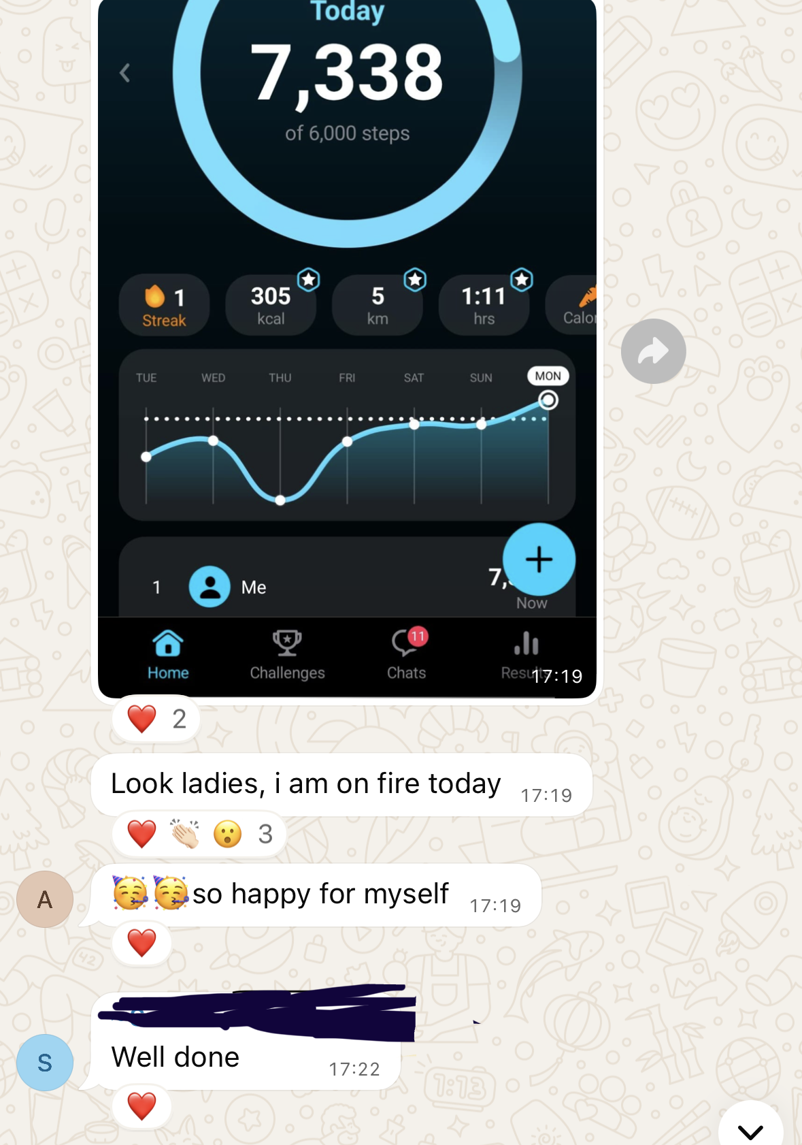
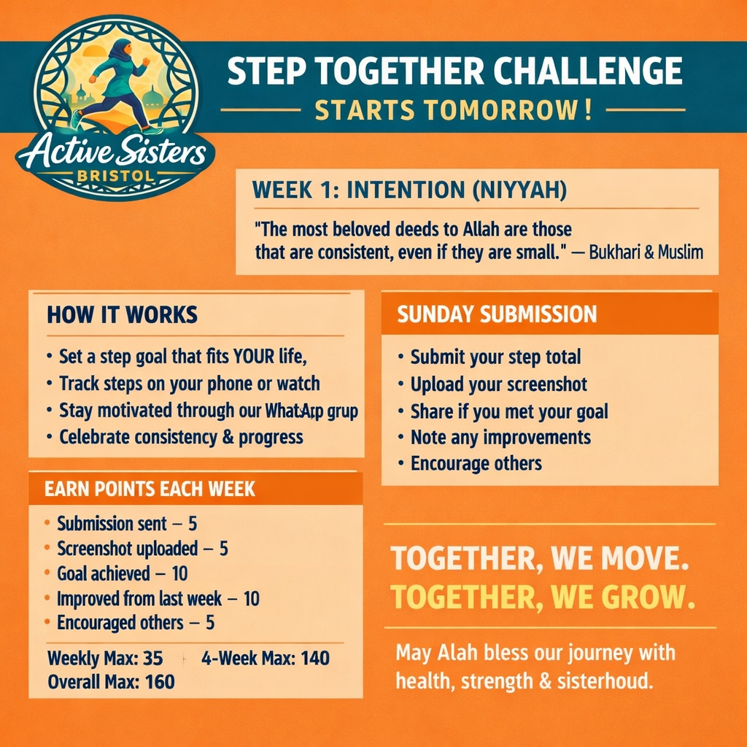

Fig 5: Example WhatsApp posts as part of the Step Together Challenge

This programme created a community of women willing to get active, but in need of social encouragement and support. Through the shared faith values of the participants, the programme used Islamic-inspired motivational quotes and insights to encourage the women and engage with and maintain physical activity. The shared experience among group members (work, family responsibilities and other similar barriers to physical activity) enabled women to support and motivate one another, reducing feelings of isolation and increasing confidence to participate. Through discussing common challenges, participants developed a sense of understanding and mutual support that helped them overcome barriers to engagement. A participant wrote:
“This week didn't go as I had hoped for various reasons but one thing I can honestly say is that this group has kept me motivated over the past four weeks seeing everyone's progress reading your updates celebrating the wins and encouraging one another has been genuinely inspiring every step no matter how small counts and the positivity in this group has made a real difference”
Members reported outcomes beyond increasing step count (fig: 5); including:
improved mental wellbeing, feeling a sense of belonging and positivity and even starting weight loss journeys.
“Getting myself to think about myself, my wellbeing, my health, my happiness”
“Alhamdulillah because of this group at least I started my weight loss journey, I am feeling very active and energetic thank you for giving me this chance”

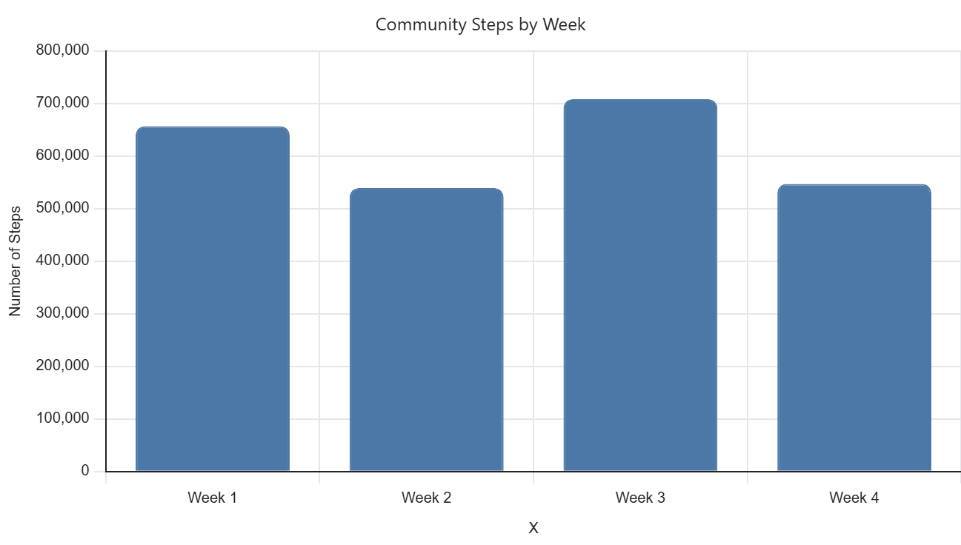
Fig 6: Community steps recorded during the four-week walking challenge.
Participants collectively achieved 2,450,914 steps, with the highest number of steps recorded in Week 3 (708,154).
Among the 16 participants who completed the programme evaluation, 13 reported that they intended to continue walking regularly, while two indicated that they were likely to do so. Confidence levels increased from 6.4/10 before the challenge to 8.5/10 at the end of the four-week programme.
Flexibility was essential in this pilot. Work, family responsibilities, illness, holidays and weather all affected participation. This reinforced the importance of realistic, rather than perfection-focused, activity opportunities. Participants also highlighted limitations in relying on phones alone to record steps. Future challenges could consider simple activity trackers or smartwatches where appropriate. Figure 6 shows further feedback from the participants.

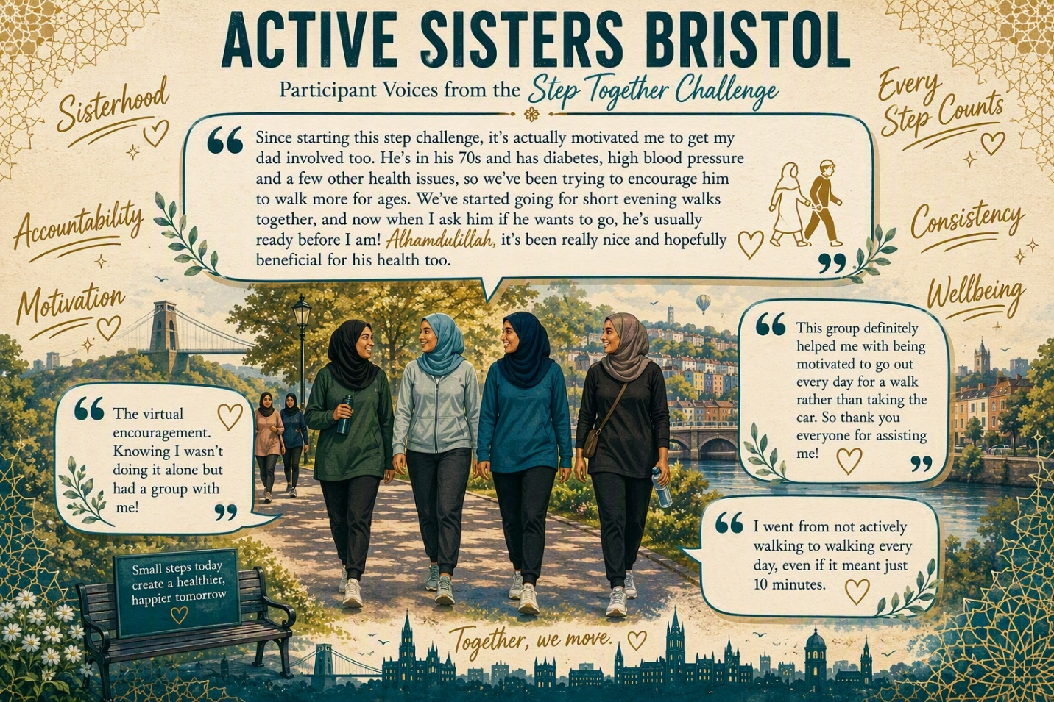
Fig7 & 8 (below): Participant voices from the Step Together Challenge.

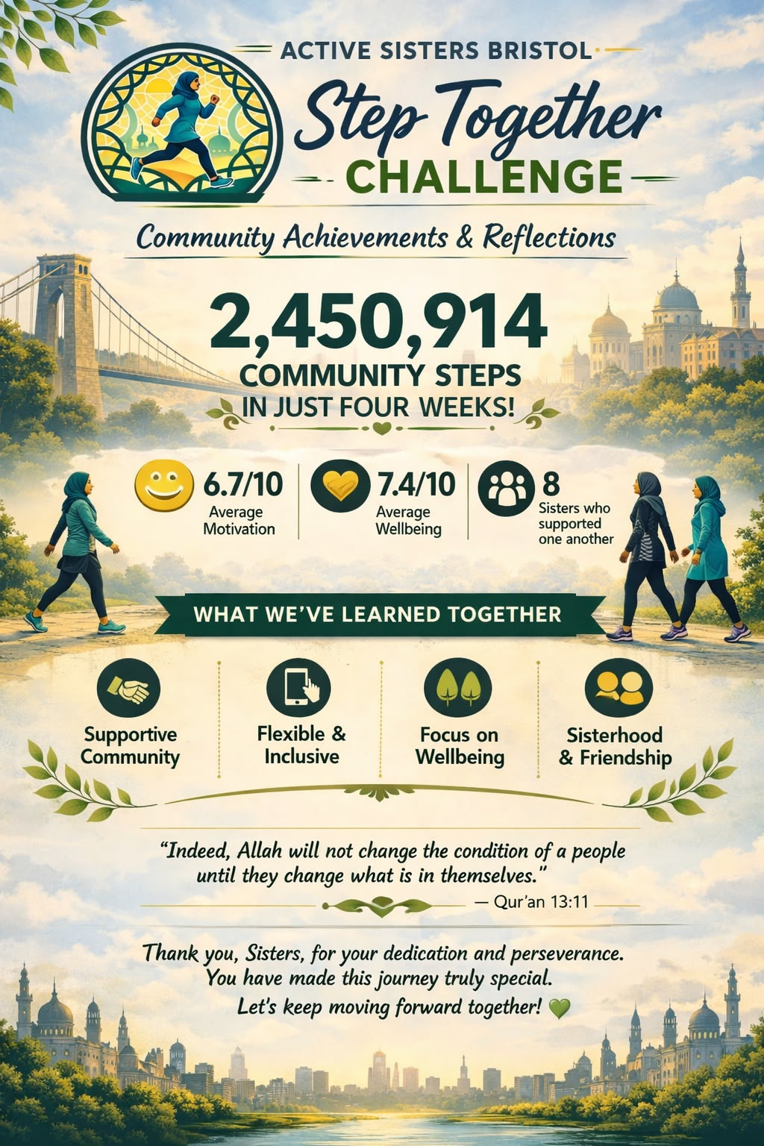

The ripple effect
The impact of the Step Challenge extended beyond the four-week activity itself.
One participant subsequently joined a hiking group, demonstrating how a relatively simple supported challenge can provide a stepping stone into further physical activity.
This is an important example of the ripple effect that Active Sisters Bristol was seeking to create:
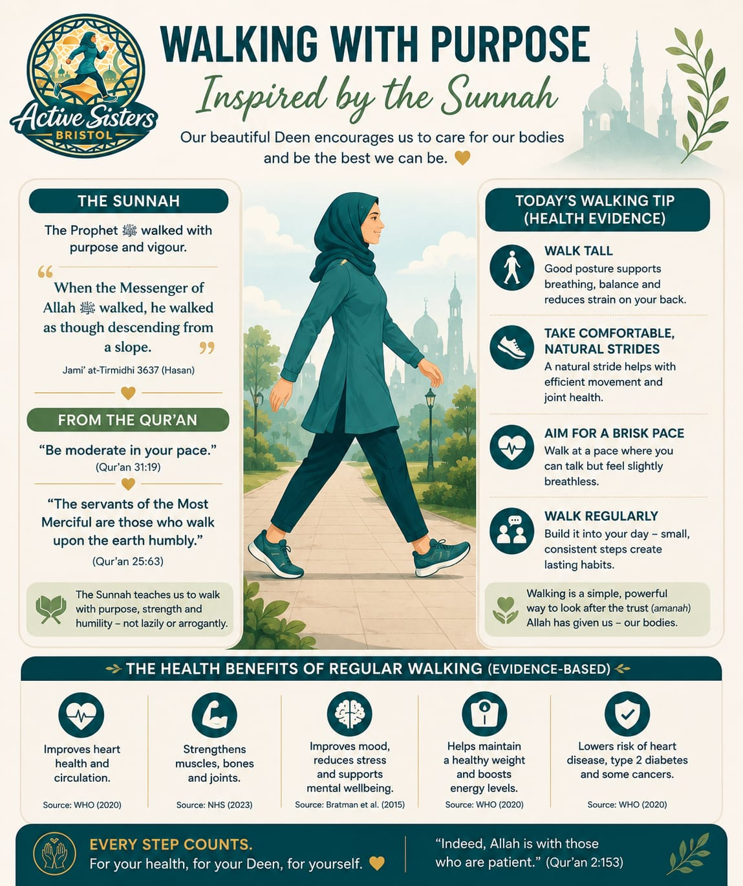
Participation → confidence → motivation → trying something new → sustained activity

Fig 9: Walking with Purpose

The project therefore created opportunities for movement beyond the original pilot activities, rather than simply measuring success by attendance during the funded period.
2,450,914 steps were recorded — but the more important question is what those steps set in motion.

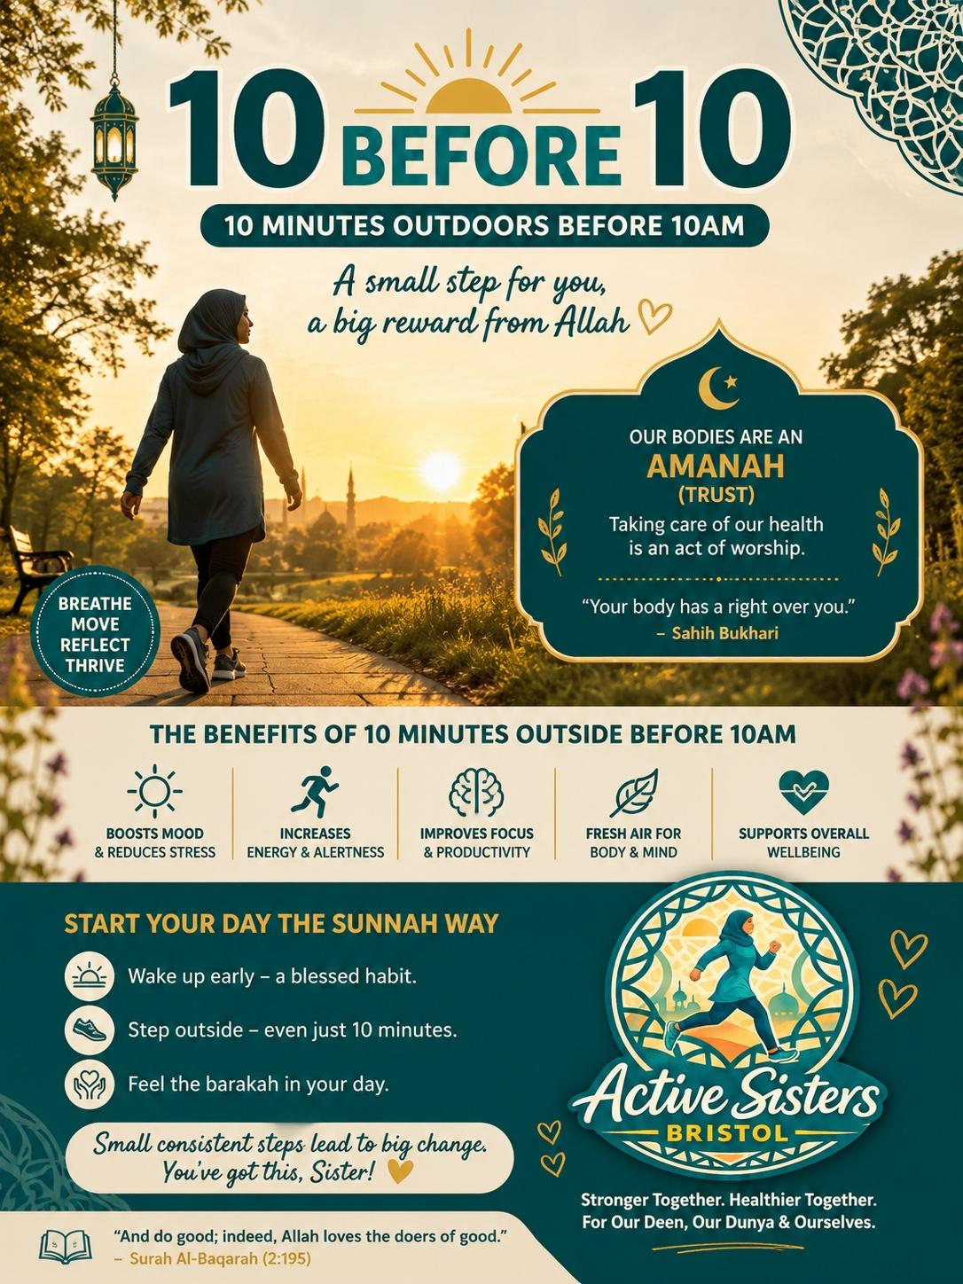
Fig10: 10 Before 10

4.2 Strength & Flexibility
The Strength & Flexibility pilot programme tested whether beginner-friendly, women-only structured exercise could increase Muslim women and girl’s engagement with physical activity. It included a four-session block of female-instructor led tailored exercises delivered in June-July 2026 at Fishponds Old Library at a low cost.
The programme combined strength, mobility, balance, flexibility and cardiovascular activity, and the equipment was adapted to help women with physical disabilities engage with the programme.

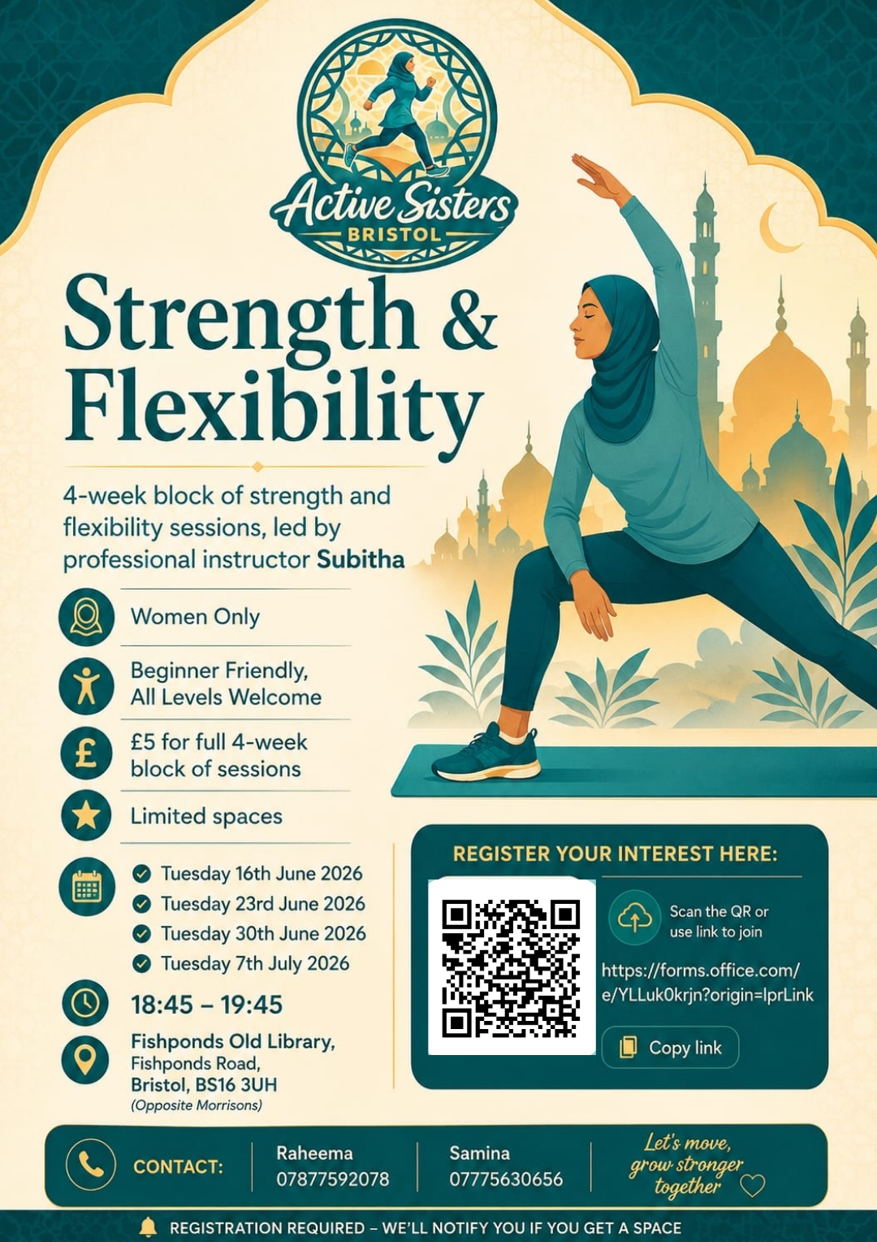

Fig 11: Promotion poster for the Strength and Flexibility sessions
Participation in the strength and flexibility exercise programme was supported by a combination of practical, social, and organisational factors. These included a familiar and accessible location, good transport links, an all-women setting, convenient session times, coordinator support, and the availability of block booking, all of which helped make attendance easier and more sustainable for a diverse range of women. Attendance remained consistently high throughout the programme, despite the occurrence of multiple heatwaves during the delivery period.
Overall feedback from the 16 participants was highly positive: 13 (81%) rated the sessions as excellent and 3 (19%) as good. The sessions were also rated highly for being welcoming (12 excellent, 3 good) and suitable for participants' fitness levels (9 excellent, 7 good).
Of the 16 participants, 14 reported increased motivation to exercise, 13 felt more comfortable attending women-only activities, and 13 were inspired to try other activities. 12 participants reported being more likely to continue exercising, while 9 felt more confident about being physically active. Self-reported confidence increased substantially, rising from an average of 6.8/10 before the programme to 8.5/10 afterwards.
Qualitative feedback reinforced the importance of beginner-friendly delivery, a supportive female instructor, women-only space, privacy, affordability, accessibility and a friendly atmosphere. Participants particularly valued being able to work at their own pace and having exercises adapted to different abilities. Below are some quotes to illustrate participants’ feedback:
“Thank you so much for everything I have been more active in this past year than ever before in my life and they are all new initiatives. I've tried new things I didn't even know existed and enjoyed it more than I could have expected. As someone who has often been very loathe to any kind of movement and generally tired fatigued and stressed it has been a very positive change and I would find it difficult to continue if this type of lady sessions advertised in our community weren't running”
“Timing was excellent. Stretching after a long day was rewarding. The venue is excellent clean with all necessities. The instructor was very friendly, highly knowledgeable and experienced with people of different backgrounds levels and needs”
A key factor to the success of the pilot was the role of the programme co-ordinator who managed communication, promotion, bookings, venue arrangements and participant registration. The coordinator role on the pilot programme was unpaid and was highly reliant on their enthusiasm and community relations. Community-led does not have to mean volunteer-led. Future programme success depends on working with appropriate coordinators and valuing their time and commitment.
The role of community health ambassador/ coordinator can extend far beyond the visible delivery of activities. In developing Active Sisters Bristol, this involved elements of community research, project design, organising, relationship-building, evaluation, communication, mentoring and reporting. Much of this work is invisible when a project is viewed simply as a series of three pilot activities, but it is essential to building trust, maintaining engagement, developing partnerships and creating opportunities that can continue beyond the initial pilot.

4.3 Netball
The netball pilot explored Muslim women and girls’ engagement with team sports, welcoming participants of diverse ages and levels of experience. The programme offered the option of “Bring a Friend” reducing the cost of 3 sessions from £10 per person for the block of 3 sessions to £15 for two people for the block of sessions. Out of 20 people who took part, 14 chose the Bring a Friend option. Figure 12 shows an example promotion poster for the Netball sessions. Participant comments highlighted the combination of sport, friendship, confidence and belonging as a key aspect of the programme. One participant described the sessions as a way to “make new friends, acquaintances and get active all at the same time”, while another said the women-only and private environment “made all the difference”.

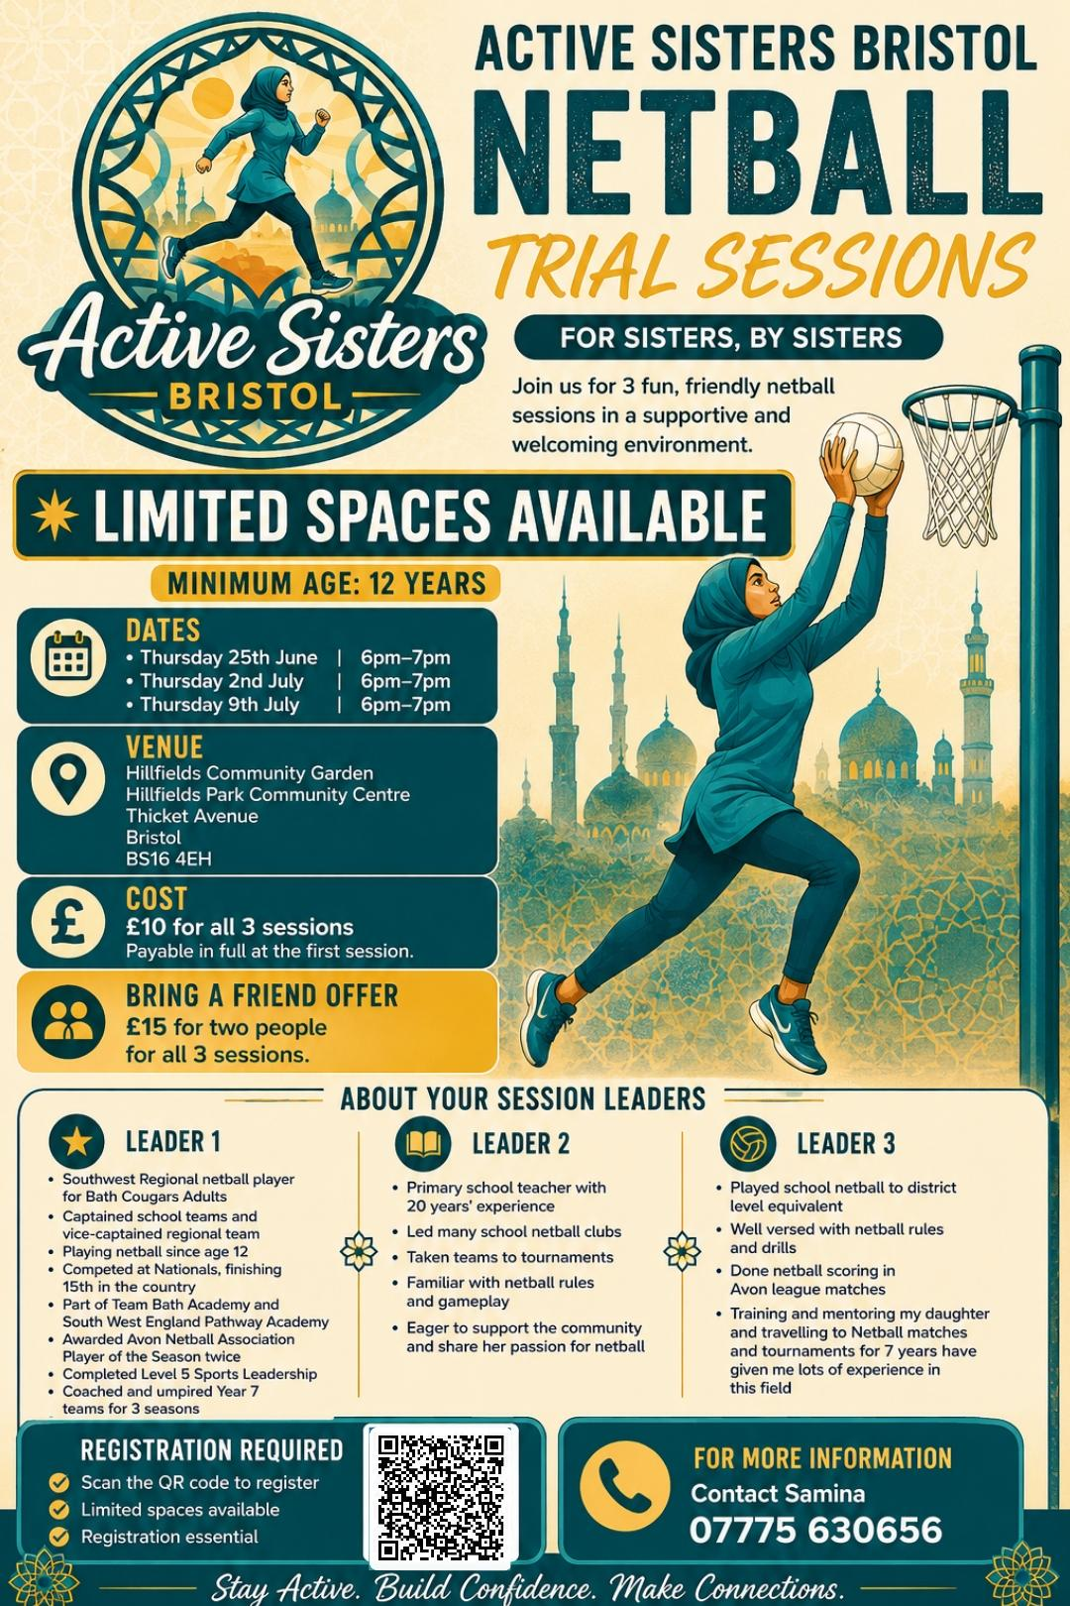

Fig 12: Promotion poster for the Netball sessions
The programme received highly positive feedback and participants reported a range of outcomes including:
- 12 out of 15 who completed the evaluation said they would definitely or probably continue if sessions became regular. 14 wanted sessions weekly or more than once a week.
- Self-rated confidence in physical activity increased from an average of 6.7/10 before the trial to 9.2/10 afterwards. Following the sessions, 12 participants said they felt more comfortable attending women-only activities, 11 felt inspired to try other activities, and 9 felt more motivated to exercise.
- Women reported feeling more confident to be physically active, more likely to continue exercising, less stressed, more energetic and more connected with other Muslim women.
In terms of factors affecting engagement with the programme, 13 of the 15 women said that the women-only, culturally sensitive setup made it easier for them to attend; seven said they would not have attended without this arrangement and six were unsure. The image below illustrates some of the feedback received from the participants.
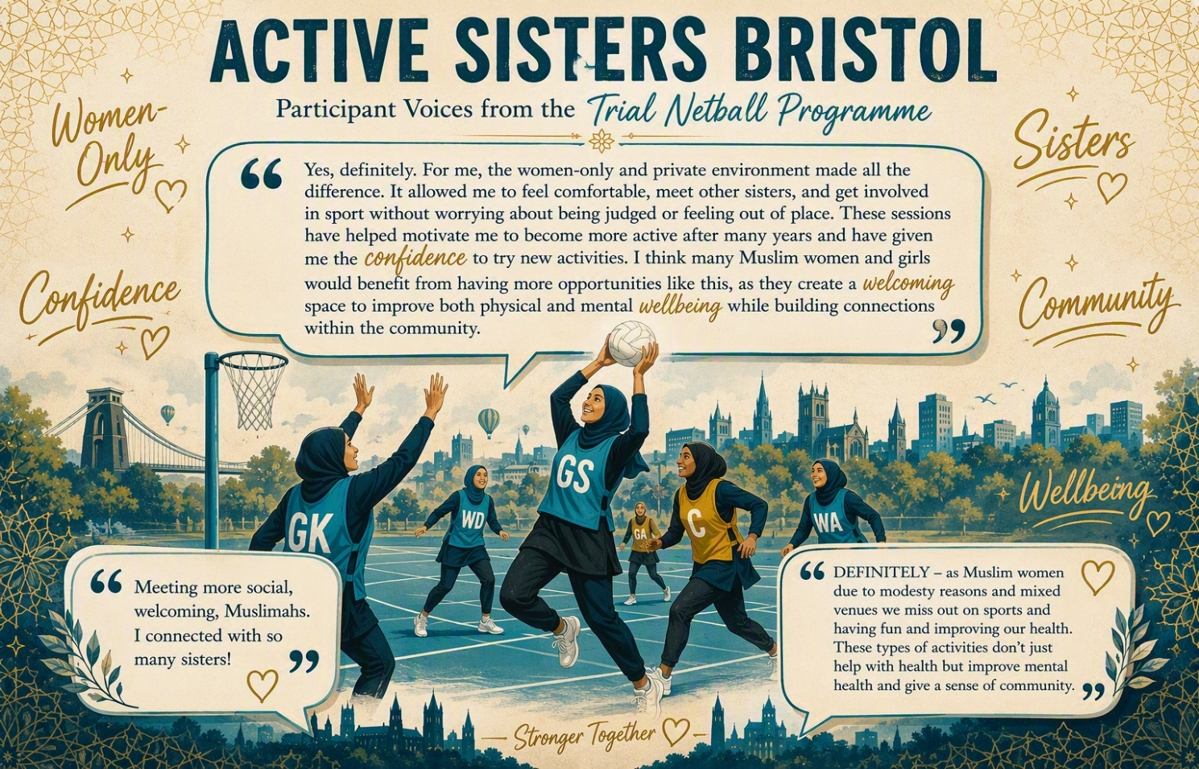
Fig 13: Participant voices from the Netball pilot.

Cost and Delivery Considerations
While the pilot programmes were designed primarily to test engagement and participation, they also provided valuable insight into the resources required to deliver community-based physical activity opportunities.

Step Together Challenge
The Step Together Challenge was the lowest-cost intervention in financial terms, but the most labour-intensive to deliver.
Direct costs included:
- Weekly incentives, vouchers and prizes.
- Promotion and participant communications.
Hidden delivery costs included:
- Managing participant registrations.
- Monitoring and collating weekly step submissions.
- Chasing incomplete responses.
- Creating and sharing weekly WhatsApp communications and motivational content.
- Providing encouragement, accountability and participant support throughout the challenge.
- Analysing participant data and outcomes.
- Coordinating participant feedback and evaluation.
Although the programme required relatively little financial investment, it required substantial coordination and administration time. This highlights the importance of recognising coordinator capacity as a genuine delivery cost, even where programme expenditure appears low.

Strength & Flexibility
The Strength & Flexibility pilot involved moderate delivery costs and benefited from strong community support.
Key delivery costs and contributions included:
- Payment for a qualified female instructor.
- Venue provided free of charge, significantly reducing programme costs.
- Participants contributed a nominal fee of £5 for the entire trial period.
The participant contribution was not intended to cover delivery costs but primarily acted as a commitment mechanism to secure places and reduce non-attendance. The high demand for places suggests that affordable women-only activity delivered in trusted community settings can be highly attractive and accessible.

Netball
The Netball pilot was the most expensive programme to deliver.
Key delivery costs included:
- Venue hire.
- Session leaders and coaching support.
- Equipment and programme coordination.
Participant contributions included:
- £10 per participant for all three trial sessions.
- £15 for two participants through the Bring a Friend option.
These contributions helped offset some of the programme costs but did not fully cover delivery costs. However, the strong registration numbers, high levels of engagement and positive participant feedback suggest that team sports delivered in culturally appropriate environments can provide significant community value.

Key Learning
Across all three pilots, the project demonstrated that successful delivery depends on more than venues, equipment and instructors.
Important but often unseen costs included:
- Community coordination.
- Participant communication.
- Relationship-building and trust development.
- Recruitment and promotion.
- Booking and administration.
- Monitoring and evaluation.
- Participant support and follow-up.
- Partnership development.
These functions are critical to participation, retention and programme success, yet can often be overlooked when considering the cost of delivery. Future investment should therefore consider both direct programme costs and the coordination infrastructure required to create sustainable and inclusive opportunities for Muslim women and girls.

5. Sustaining Momentum Beyond the Pilot

Building Beyond the Original Brief
One of the most significant outcomes was that the project did not simply finish when the three pilot activities ended. Relationships and opportunities developed organically.

5.1 Padel, LTA and tennis
The project built on Padel activity is already taking place and strengthened links with the Lawn Tennis Association (LTA). This has created opportunities for more regular women's Padel, further training, exploration of tennis opportunities and community development. The LTA has also provided equipment for the community to use.
Discussions with the LTA are exploring how tennis opportunities could be developed for Muslim women and girls, broadening the range of activities while continuing to apply the learning around accessibility, culture and women's participation. A local community member has now come forward to explore this opportunity.

5.2 Developing Netball Leaders
There is exploration of training local women through the relevant netball association so that community members can become session leaders and coaches. This begins to shift the model from relying entirely on external instructors towards building skills and leadership within the community.

5.3 Pilates
There is also exploration of training local women as Pilates instructors, providing another potential progression route for women who want to develop their own skills while creating future community provision.
Wesport was instrumental in connecting Greenbank Mosque with a Pilates instructor, supporting the development of two weekly Pilates sessions now attended by around 30 women, and supporting women from the mosque to gain Level 2 Gym Instructor qualifications, with one progressing to REACT falls prevention training.

Willingness to help
Within the Active Sisters research, WeSport helped connect participants with England Netball Association and supported the netball sessions, while exploring a pathway towards sustainable delivery and potentially supporting participants to become coaches.
WeSport also highlighted the value of the research in understanding the experiences, needs and barriers faced by women and girls and ensuring future approaches are informed by their voices and experiences. They expressed an interest in continuing to work with partners and communities to translate the findings into meaningful and sustainable opportunities across Bristol.

The ripple effect
The project created movement in more than one sense. The original pilots were intended to test what might work; the subsequent opportunities show how participation can lead to further activity, relationships and leadership. Figure 14 illustrates the ripple effect created by this project. One of the most encouraging outcomes has been the potential for women to move beyond being participants.
- Encouraging others
- Supporting relatives
- Sharing ideas
- Helping mobilise community members
- Considering leadership opportunities
- Exploring training
- Mentoring other community members

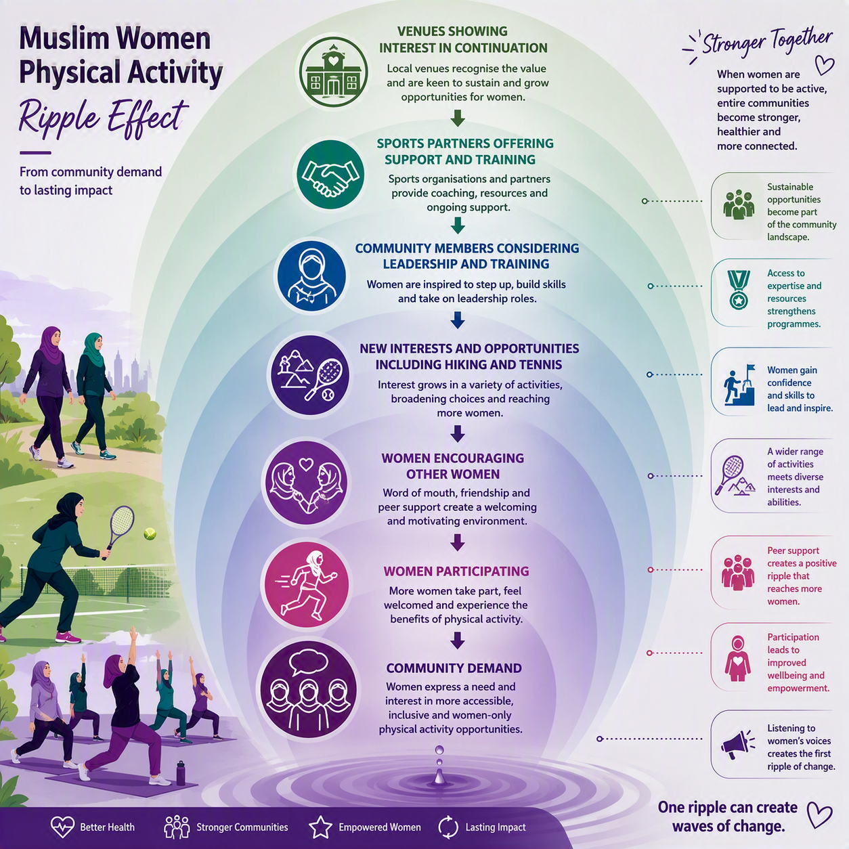

Fig 14: Ripple effect created by offering culturally sensitive physical activity programmes to Muslim women and girls in Bristol

6. BEYOND THE BRIEF

The Emergence of an Active Sisters Bristol Identity
The development of the Active Sisters Bristol name and branding was not part of the original brief. However, it became an important outcome of the project.
The brand provided a recognisable identity, a way of connecting different activities, a sense of belonging, greater visibility and a platform for future opportunities.
Importantly, the preferred logo was tested with the community through a WhatsApp poll, with 100% of respondents preferring the selected logo below as the more inclusive option.

Active Sisters Bristol
By Active Sisters, for Active Lives.
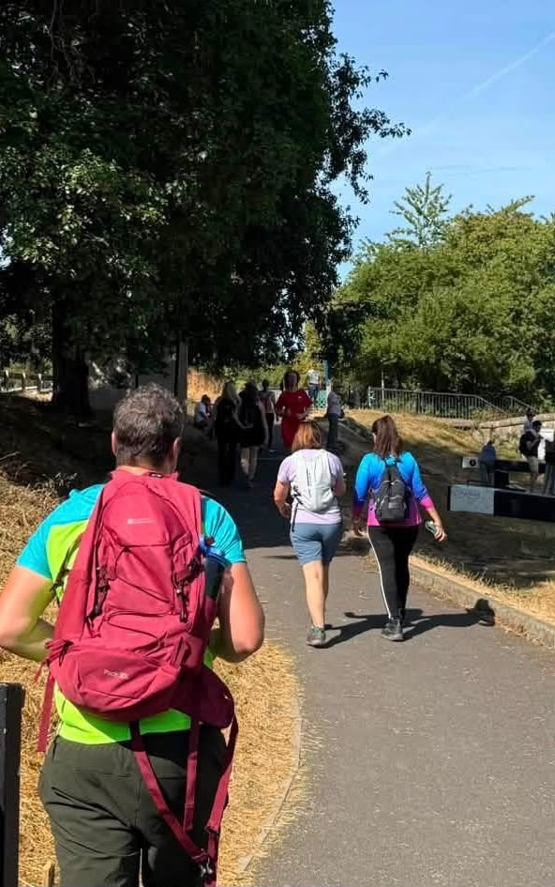
Fig 15: A Step Challenge participant subsequently joined a hiking group — an example of activity continuing beyond the pilot.

7. COMMUNITY CAPACITY

From Participants to Leaders
One of the most encouraging outcomes has been the potential for women to move beyond being participants.
- Encouraging others
- Supporting relatives
- Sharing ideas
- Helping mobilise community members
- Considering leadership opportunities
- Exploring training
- Mentoring other community members
PARTICIPANT → VOLUNTEER → COMMUNITY LEADER → TRAINED INSTRUCTOR
Potential opportunities include netball coaching, Padel development, tennis, Pilates and other physical activity qualifications.

8. WHAT THE PROJECT HAS TAUGHT US
Culturally inclusive physical activity is not simply about providing a session or venue. It is about creating the conditions in which women feel comfortable to participate, supported to continue and empowered to shape what happens next.

Relationships matter
Trust and community presence created the foundation for engagement.

Choice matters
Walking, structured exercise and team sport provide different routes into activity.

Culture matters
Cultural inclusion goes beyond simply making a session women-only.

Social connection matters
Encouragement, accountability and sisterhood can support participation.

Inclusion needs to be practical
Venue, transport, timing, affordability, privacy and accessibility all matter.

Progress looks different for everyone
Success should not only be measured by the highest step count or sporting performance.

Community leadership matters
Participants can become advocates, volunteers, leaders and instructors.

Community capacity needs investment
Coordination, communication, relationship-building, promotion, organisation and partnership development all take time.

9. LIMITATIONS
This was a relatively small-scale pilot project delivered within Bristol and findings should be interpreted within that context. The project was designed as a test-and-learn initiative rather than a large-scale research study.
Several outcomes reported in this report are based on participant self-reported measures, including confidence, motivation, wellbeing and intentions to continue being physically active. While these findings provide valuable insight into participant experiences and perceived benefits, they may not necessarily reflect longer-term behaviour change or objectively measured physical activity outcomes.
The project focused on understanding the experiences, barriers and preferences of Muslim women and girls who chose to engage with the research and pilot activities. As with many community-based projects, the findings may not represent the experiences of all Muslim women and girls across Bristol, particularly those who remain disconnected from community networks or physical activity opportunities.
Despite these limitations, the project provides valuable community insight and early evidence regarding the factors that support participation in physical activity among Muslim women and girls. Future research and evaluation could explore longer-term participation, sustained behaviour change, health and wellbeing outcomes, reach into underserved groups, accessibility, sustainability and cost-effectiveness

10. RECOMMENDATIONS
The Active Sisters Bristol project has demonstrated both clear demand for culturally responsive physical activity and the importance of how opportunities are designed, communicated and sustained. The recommendations below focus on building on the learning from the test-and-learn phase and creating the conditions for longer-term community participation.

Invest in Community Capacity and Coordination
Future funding should recognise that meaningful community engagement requires time, relationships and coordination. Community-led approaches should not automatically mean volunteer-led approaches.
Consider a funded part-time coordination role to support the continued development of Active Sisters Bristol, including community engagement, communications, activity coordination, participant support, partnership development, safeguarding, evaluation, leadership development and future funding opportunities.
The pilot demonstrated that this coordination is an essential part of the infrastructure behind successful community activity.

Develop a Clear Post-Pilot Continuation and Sustainability Plan
The pilots generated clear interest in continuing physical activity opportunities beyond the test-and-learn period, with participants expressing interest in ongoing sessions and new opportunities already beginning to emerge.
A clear post-pilot plan should therefore establish what can continue, how activities will be funded and coordinated, and how participants will be kept informed about future opportunities.
Managing this transition well is important not only for sustainability, but also for maintaining the trust built through the project. Where a project has encouraged women to participate and created expectations about future opportunities, communication about what happens next should be clear and transparent.

Build on Existing Community Leadership and Partnerships
Recognise and build on the significant work already being undertaken by community members, volunteers, mosques, community organisations, sports organisations and other partners to support women and girls to be active.
Future development should seek to connect and strengthen these existing efforts rather than duplicate them. This could include creating pathways for women and girls to move from participation into leadership, volunteering, mentoring, coaching and training, while continuing to develop relationships with national governing bodies, sports organisations, mosques, community organisations, health partners, venues and local activity providers.
The emerging opportunities around netball, Padel, tennis and Pilates demonstrate the potential for existing community relationships and partnerships to create further opportunities when the right support, connections and resources are available.

Maintain the Test-and-Learn Approach
Continue to use a test-and-learn model rather than assuming that one programme or activity will meet the needs of all Muslim women and girls.
Future activity should continue to ask:
- Who is participating and who is not?
- What activities do women and girls want?
- What prevents continued participation?
- What support would make participation easier?
- Which approaches are sustainable?
- What needs to change based on community feedback?
This will allow Active Sisters Bristol to remain responsive as community needs and opportunities evolve.

Build Cultural Relevance Into Physical Activity and Health Promotion
Cultural inclusion should extend beyond providing women-only sessions. Future activity should consider privacy, modesty, female instructors, language, family responsibilities, affordability, accessibility, local venues and the social and cultural context in which women make decisions about physical activity.
Short, accessible motivational talks could also be explored alongside physical activity opportunities, connecting movement, physical health and wellbeing with Islamic values and teachings.
These could help participants understand physical activity as part of caring for the body, maintaining wellbeing and developing sustainable healthy habits. Where appropriate, sessions could be delivered with trusted community members or speakers who understand both the cultural context and the health messages being shared.

Explore Wider Healthy Lifestyle and Digital Opportunities
The learning from Active Sisters Bristol suggests that physical activity can provide a platform for wider conversations about health and wellbeing.
Future development could explore complementary opportunities around healthy eating, wellbeing and prevention, alongside digital tools that support motivation, activity challenges, progress tracking, communication and signposting.
Any extension should be based on further community insight and should add value to existing community connections rather than replace them.

Strengthen Research, Evaluation and the Public Health Learning
Active Sisters Bristol provides valuable community insight and early evidence of what can support participation, but further research and evaluation would strengthen the evidence base.
Future evaluation could explore longer-term participation, sustained behaviour change, reach into underserved groups, physical and mental wellbeing outcomes, accessibility, sustainability, community empowerment and cost-effectiveness.
Future research should continue to centre the voices and lived experiences of women and girls and explore not only whether an approach works, but why it works, for whom and under what circumstances.
The learning from Active Sisters Bristol should also be considered more broadly as an example of how trusted community relationships, lived experience, partnership working and test-and-learn approaches can contribute to prevention, increased physical activity, wellbeing and the reduction of health inequalities.

FINAL REFLECTION
2,450,914 STEPS
But the real achievement cannot be measured in steps alone.
It can be seen in the women who made time for themselves; the sisters who encouraged one another; women who tried something new; those who kept going through difficult weeks; women returning to sport; the participant who could take part without feeling that her disability made her stand out; the partnerships that developed; women considering training and leadership opportunities; and a community beginning to shape what physical activity could look like for itself.
The numbers tell part of the story.
The community tells the rest.

LISTEN. LEARN. MOVE TOGETHER.

Acknowledgement
I would like to acknowledge the support, relationships and opportunities that have enabled Active Sisters Bristol to take place.
I am deeply grateful to everyone who contributed their time, knowledge, encouragement and expertise, and especially to the women and girls who trusted us enough to take part and share their experiences.
I would also like to acknowledge the support of our community, sport and delivery partners, whose contributions helped turn ideas into practical opportunities.

Author Reflection
For me, this work is about more than delivering a project. It is about creating positive change, building trust and opening doors that may not otherwise be accessible.
On a personal level, I recognise that I have been able to undertake this work by the will of Allah. I pray that the learning from Active Sisters Bristol will continue beyond this project and that it will contribute, in some way, to creating healthier opportunities for women and girls and reducing health inequalities for future generations.
I hope that the relationships, learning and opportunities created through Active Sisters Bristol will have a lasting benefit for the community and that someone, somewhere, will genuinely benefit from the work that has been undertaken.

